ASSIGNMENT-3

Group-4:

2303A51L58 V. Chandan

2303A51L59 V. Vaishnavi

PEN MICROPHONE SUMMARISER

1.Identifying problem statement and their solutions in tests.

ABSTRACT:

a pen having microphone with summariser to summarise everything what we record. It works based on the algorithms and easily captures and summarises the audio into understandable format. It is different from other pens because it has speaker with summariser.

Problem statement:

When we want to listen a lecture for long time we could not remember the whole lecture at once. We lose the interest at times in the middle of the class.

To avoid This Type of consequences we provide a gadget which records the audio and summarises the audio in simple format.

Existing problem in gist:

Innovative PENSUM device: It is a specialised device which is used to record audio and summarise the given audio so that every one can easily understand.

We can always memorize the audio and also record the lectures for better understanding.so that we can have an idea about everything what’s going on in the lecture. This device works in efficient manner.

We provide 250MB of memory storage and battery life up to 20hrs.

* It works through the dual upgraded noise cancelling microphones with professional recording chip.
* It captures crystal clear audio recording for lectures, interviews.
* Automatic saving option
* Easy files management to find recorded audios
* It consists a micro phone so that we can listen to the summarised audios.

2. Using google patents, do validity tests to state its novelty and innovation of problem statement:

PATENT VALIDITY TESTS:

Pen type computer

Wireless pen input device

Multi-purpose stylus for a computing device

Enhancing audio recording for smart pen computing system

Multi-user collaboration with a smart pen system

Video-based handwriting input

**COMPARATIVE ANALYSIS :**

|  |  |  |
| --- | --- | --- |
| PATENTS | EXISTING SYSTEM | PROPOSED SYSTEM |
| US7570253B2-  PEN TYPE COMPUTER  UNITED STATES | It has a sensor encoding the tracking signal into data and storing the data in storage device. | It has a sound sensor which is used to record the voice and stores in storage device. |
| US20020025289A1-  WIRELESS PEN INPUT DEVICE  UNITED STATES | It has a microphone and power supply to record the information. | It also consists microphone but the recorded information is summarised. |
| US7889928B2-  VIDEO-BASED HANDWRITING INPUT  UNITED STATES | It has a camera which records and click pictures and convert the picture into an information. | It has a microphone and speaker which records and writes the information at same time. |
| US20130307829A1-  HAPTIC-ACOUSTIC PEN  UNITED STATES | It has an electronic screen at the top of the pen which displays the recorded videos. | It does not consist the display screen but just records the information and speaks out in summarised manner. |
| KR102407071B1-  MULTI-DEVICE MULTI-USER SENSOR CORRELATION FOR PEN AND COMPUTING DEVICE INTERACTION  SOUTH KOREA | It simply focuses on the grip of the pen and it is touch-sensitive. | It has fine grip which allows us to write the information easily at same time both activities can be performed. |

Social impact:

1.Education: Student could easily understand the lectures and can easily summarise the syllabus.

2.Communication: In meetings we could use pen to capture key points or to summarise the conversations.

3.Efficiency: We can easily carry it any where and don’t bother about the carrying notes everywhere.

4.Usability: It is user-friendly so even an uneducated person also can use.

INDUSTRIAL IMPACT:

* It could revolutionize note-making and transcription processes more efficient and accessible
* It leads to advancements in language processing technologies.
* This technology could have implications for conferences, meetings journalism.

TARGET AUDIENCE:

These pen targets the audience to capture the conferences, meetings and can work while recording the audio. By the auto save option we can easily save our work without any hesitation.

COST OF DEVICE:

Microphone-2499

Sound sensor (model no:LM393)-170

Speaker-60

Total cost:2729

3D-DESIGN:

FRONT VIEW:

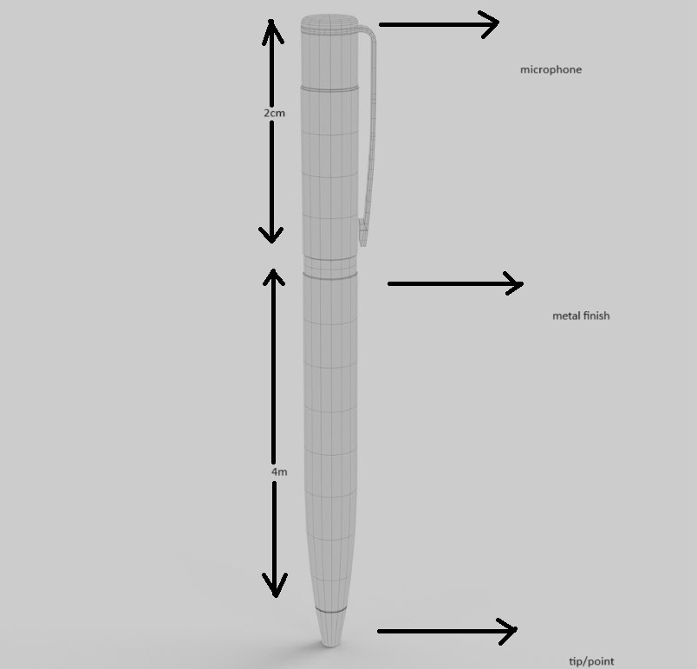

LEFT SIDE VIEW:

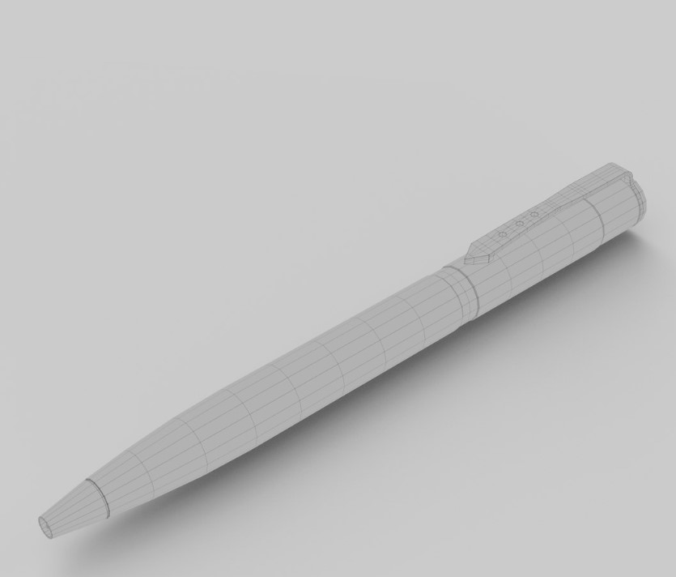

RIGHT VIEW:

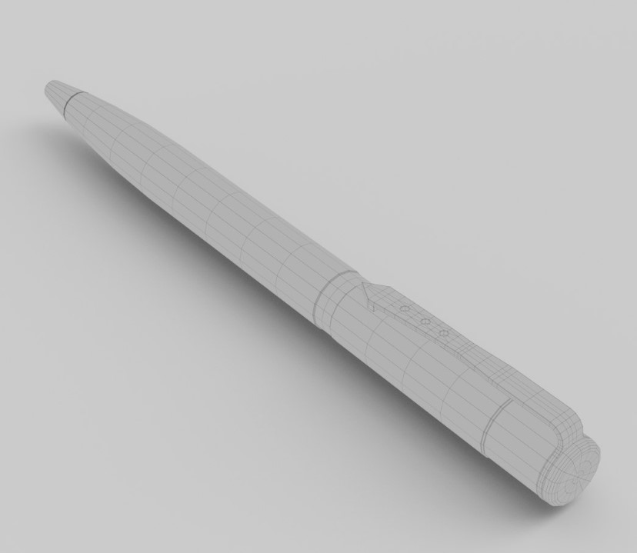

ALGORITHMS:

ASR algorithm: Automatic speech Recognition algorithm

It converts the spoken language into written text by analyzing audio input into speech segments, and segments into text.

NLP algorithm: Natural language processing algorithm

It enables efficient processing and analysis of spoken content, facilitating tasks such as note-making, content summarization.

DATA FLOW DIAGRAM:

